Specification Grid-2081
Class:-1
Sub:- Science

1st Term Total Working Days:- 57
Science - 1, 2, 3, 4, 5
Health - 20, 21
Physical Education - 26, 27
Lesson should be finished for first term exam.

2nd Term Total Working Days:- 44
Science - 6, 7, 8, 9, 10
Health - 22, 23
Physical Education - 28, 29, 30
Lesson should be finished for second term exam.

3rd Term Total Working Days:- 55
Science - 11, 12, 13, 14, 15
Health - 24, 25
Physical Education - 31, 32, 33
Lesson should be finished for third term exam.

Final Term Total Working Days:- 42
Science - 16, 17, 18, 19
Physical Education - 34, 35
Lesson should be finished for final term exam.

First Terminal Examination Grid :-2081
Class:-1 F.M=50
Sub:- Science P.M= 20
S.N. | Types of questions | No of Q.N | Opt | Q.N to be done | Weight | Total
1. | Fill in the blanks. | 4 |  | 4 | 1 | 4
2. | True or False. | 4 |  | 4 | 1 | 4
3. | Match the following. | 4 |  | 4 | 1 | 4
4. | Choose the correct answer. | 4 |  | 4 | 1 | 4
5. | Circle the odd one. | 4 |  | 4 | 1 | 4
6. | Fill in the missing letters. | 4 |  | 4 | 1 | 4
7. | Re-arrange the letter. | 4 |  | 4 | 1 | 4
8. | Write the name of the following. | 4 |  | 4 | 1 | 4
9 | Answer the following question. | 7 | 1 | 4 | 1 | 12
10 | Give the definition. | 2 |  | 2 | 1.5 | 3
11 | Draw the picture. | 1 |  | 1 | 3 | 3

2nd , 3rd , 4th Terminal Examination Grid :-2081
Class:-1 F.M=50
Sub:- Science P.M= 20
S.N. | Types of questions | No of Q.N | Opt | Q.N to be done | Weight | Total
1. | Fill in the blanks. | 4 |  | 4 | 1 | 4
2. | True or False. | 4 |  | 4 | 1 | 4
3. | Match the following. | 4 |  | 4 | 1 | 4
4. | Choose the correct answer. | 4 |  | 4 | 1 | 4
5. | Circle the odd one. | 4 |  | 4 | 1 | 4
6. | Fill in the missing letters. | 4 |  | 4 | 1 | 4
7. | Identify the following. | 4 |  | 4 | 1 | 4
8. | Write the name of the following. | 4 |  | 4 | 1 | 4
9 | Answer the following question. | 7 | 1 | 4 | 1 | 12
10 | Give the definition. | 2 |  | 2 | 1.5 | 3
11 | Draw the picture. | 1 |  | 1 | 3 | 3

First Terminal Examination
Model Questions - 2081
Class:-1 Time:- 2:00 Hrs F.M=50
Sub:- Science P.M= 20

Q.1) Fill in the blanks. 4x1=4
( living things, towel, two, grow)
- Cow is a ..................
- We should wipe our face with a clean ...............
- I have a ................ eyes.
- Non- living do not ...............
Q.2) True or False. 4x1=4
- Living things do not move.
- Tiger and cat do not eat food.
- Non-living grow.
- Tiger and lion are herbivores animals.
Q.3) Match the following. 4x1=4
- Walking Non-Living things
- Book Legs
- Herbs Flower
- Rose Very small plant
Q.4) Choose the best answer. 4x1=4
- Tiger is a ..................... animals. (Omnivores/Carnivores)
- Apple is a ...................... plant. (Small/Big)
- Tree are ........................ things (living/Non-living)
- Most plants are ..................... in color. (green, red)
Q.5) Circle the odd one. 4x1=4
- Cow Goat Hen
- Sheep Bear Fox
- Rose Lily School
- Stone House Tree
Q.6) Fill in the blanks. 4x1=4
a) S c _ o _ l b) T _ e e c) E _ r d) P_ n
Q.7) Re-arrange the letter to make word. 4x1=4
- Monkey ________________________
- Birds_____________________________
- Apple____________________________
- Net______________________________
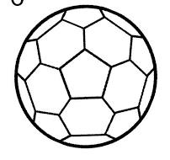
Q.8) Write the name of the followings. 4x1=4
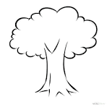
a) b)

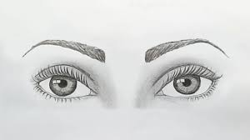
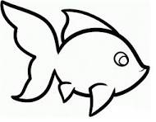
c) d)

Q.9) Answer the following Questions. 6x2=12
- Write any four living things.
Ans:-__________________________________________________________.
- Name any two body parts.
Ans:-__________________________________________________________.
- How many times do you brush your teeth in a day?
Ans:-__________________________________________________________.
- What is herbivores animals?
Ans:-__________________________________________________________.
- Write any four fruits name?
Ans:-__________________________________________________________.
- What are running?
Ans:-__________________________________________________________.
- How many ears do you have ?
Ans:-__________________________________________________________.
Q.10) Give the definitions of. 2x1.5=3
a) Cow
_________________________________________________________
__________________________________________________________
__________________________________________________________.
b) Flower
__________________________________________________________
__________________________________________________________
__________________________________________________________.

Q.11) Draw the pictures of 3x1=3
Bird Flower Umbrella

Second Terminal Examination
Model Questions - 2081
Class:-1 Time:- 2:00 Hrs F.M=50
Sub:- Science P.M= 20

Q.1) Fill in the blanks. 4x1=4
( Life, Move, two, piglet)
- Plants and animal have........................
- Animals ................... from one place to another.
- I have .......................... eyes.
- The baby of pig is called................................
Q.2) True or False. 4x1=4
- Cow and buffalo eat only plants.
- Man and Bear are omnivores.
- Dog eat both plants and flesh.
- Food gives us energy to do work.
Q.3) Match the following. 4x1=4
- Dog Vegetables
- Apple Puppy
- Cabbage Fruit
- Tree Living Things
Q.4) Choose the best answer. 4x1=4
- A ..................... lays eggs. (goat/hen)
- I comb my .......................regularly. (hair/teeth)
- Plants are........................... things. (living/Non-living)
- Buffalo have both horn and .......................... (tail, sail)
Q.5) Circle the odd one. 4x1=4
- Sheep Cow Fox
- Cabbage Tomato Rice
- Nose Eye Pen
- Tree Cow Book
Q.6) Fill in the missing letters. 4x1=4
a) P _ P _ Y b) Z _ B _ A c) N _ S _ d) M _ _ TH
Q.7) Identify the following 4x1=4
- You use to me collect waste ___________
- I live in a den _________
- I am a baby of cat _________
- We get honey from a _________
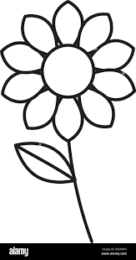
Q.8) Write the name of the followings. 4x1=4

a) b)

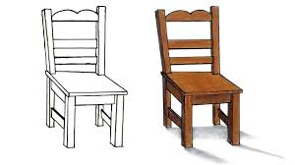
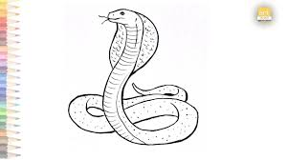
c) d)

Q.9) Answer the following Questions. 6x2=12
- Name any two body parts of fish .
Ans:-__________________________________________________________.
- What are living things?
Ans:-__________________________________________________________.
- What is the name of baby tiger ?
Ans:-__________________________________________________________.
- Write any two flowers name.
Ans:-__________________________________________________________.
- What are omnivores animals?
Ans:-__________________________________________________________.
- Why should we take physical training daily?
Ans:-__________________________________________________________.
- Name any two vegetables.
Ans:-__________________________________________________________.
Q.10) Give the definitions of. 2x1.5=3
a) Tree
_________________________________________________________
__________________________________________________________
__________________________________________________________.
b) Herbs
__________________________________________________________
__________________________________________________________
__________________________________________________________.

Q.11) Draw the pictures of 3x1=3
Apple Fish Flower

Third Terminal Examination
Model Questions - 2081
Class:-1 Time:- 2:00 Hrs F.M=50
Sub:- Science P.M= 20

Q.1) Fill in the blanks. 4x1=4
( Fly, domestic, wings, animals)
- We should take care of ..................
- Wings are used to ........................
- Cow is a ...........................
- Birds have feathers and ............................
Q.2) True or False. 4x1=4
- Birds do not have wings.
- We should not follow traffic rules.
- We should take care of animals.
- We get milk from cows and buffaloes.
Q.3) Match the following. 4x1=4
- Birds Water sources
- Lake Fresh
- Tree wings
- Football Round shape
Q.4) Choose the correct answer. 4x1=4
- Cow moves by ............................ (flying/walking)
- We need air to .......................... (walk /breath)
- We get milk from ........................... (dog/cow)
- We tase with our ......................... (nose/tongue)
Q.5) Circle the odd one. 4x1=4
- Parrot Vulture Crow Fox
- Running Drinking Cooking Washing
- Tiger Fox Pencil Elephant
- Apple Orange Rice Mango
Q.6) Fill in the missing letters. 4x1=4
a) B O _ K b) G R _ W c) H _ ND d) P l _ N T
Q.7) Identify the following. 4x1=4
- I have a wings ___________
- I am a having a round shape _________
- We get honey from _________
- I live in a den _________
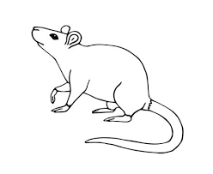
Q.8) Write the name of the followings. 4x1=4
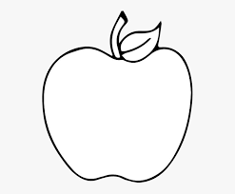
a) b)

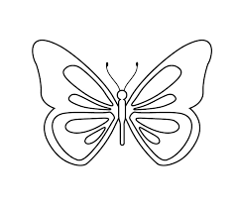

c) d)

Q.9) Answer the following Questions. 6x2=12
- Name any two body parts of cow .
Ans:-__________________________________________________________.
- Name any four animals having wings?
Ans:-__________________________________________________________.
- Name any two animals that give us milk?
Ans:-__________________________________________________________.
- Write any four uses of water.
Ans__________________________________________________________.
- What are simple game?
Ans:-__________________________________________________________.
- Name any 2 local games?
Ans:-__________________________________________________________.
- What is environment ?
Ans:-__________________________________________________________.
Q.10) Give the definitions of. 2x1.5=3
a) Non- Living things
_________________________________________________________
__________________________________________________________
__________________________________________________________.
b) Flower
__________________________________________________________
__________________________________________________________
__________________________________________________________.
Q.11) Draw the pictures of 3x1=3
House

Annual Examination
Model Questions - 2081
Class:-1 Time:- 2:00 Hrs F.M=50
Sub:- Science P.M= 20

Q.1) Fill in the blanks. 4x1=4
( dog, mustard, kid, coop)
- The baby of a goat is called..................
- A ........................ guards our home.
- We get oil from ...........................
- A hen lives in a ............................
Q.2) True or False. 4x1=4
- Fire is a source of heat.
- We use umbrellas on a rainy day.
- A cow has two horns and a tail.
- We feel cold on a sunny day.
Q.3) Match the following. 4x1=4
- Sunshine teeth
- Brushing exercise
- Walking sunny day
- Stem parts of plants
Q.4) Choose the correct answer. 4x1=4
- A ............................ lays egg. (goat/hen)
- I brush my .......................regularly. (hair/teeth)
- Tree are........................... things. (living/Non-living)
- Mango is a ......................... (flower/fruit)
Q.5) Circle the odd one. 4x1=4
- Lotus Rose Pansy Rice
- Root Book Leaf Flower
- Flood Landslide Sunny Windy
- Car Bus Van Tree
Q.6) Fill in the missing letters. 4x1=4
a) C l _ U _ Y b) F _ S _ c) F _ _ D d) T _ E T _
Q.7) Identify the following. 4x1=4
- I a wild animal. I live in a ___________
- I am a baby of elephant _________
- I am a mammal but I can fly _________
- I live in a nest _________
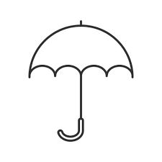
Q.8) Write the name of the followings. 4x1=4
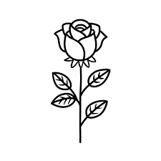
a) b)


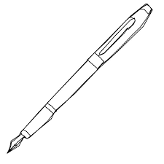

c) d)

Q.9) Answer the following Questions. 6x2=12
- How many horns does a cow have?
Ans:-__________________________________________________________.
- Write any two ways of caring for plants?
Ans:-__________________________________________________________.
- What are living things? Any one examples.
Ans:-__________________________________________________________.
- What is a cloudy day?
Ans__________________________________________________________.
- What is the name of a baby tiger?
Ans:-__________________________________________________________.
- Name any 4 animals having only tail?
Ans:-__________________________________________________________.
- What is physical training ?
Ans:-__________________________________________________________.
Q.10) Give the definitions of. 2x1.5=3
a) Tree
_________________________________________________________
__________________________________________________________
__________________________________________________________.
b) Cow
__________________________________________________________
__________________________________________________________
__________________________________________________________.
Q.11) Draw the pictures of 3x1=3
Flower
Prepared by : Sheetal Dhakal
Shree Divya Jyoti Basic School
Devchuli-12, Gaindi

Best of Luck..........

